

Functional Test Report
Inji certify 0.14.0

17 March 2026

Document History

It outlines the strategy used to ensure a comprehensive evaluation.

Version | Author | Date | Review | Affected Sections
V1.0 | Likhitha R L | 17/03/2025 | - Chaitanya Kesiraju  - Ragini Krishna | New Document

Contents

Introduction 4
Overview and Scope 4
Test Approach 4
Test Organization 4
Test Planning 5
Test Environment 5
Test Execution Report 6
Test case execution summary 6
Automation Result 7
Defect Metrics 9
Defect Metrics for the Release 0.14.0 9
Conclusion 9
QA Approval 9
Appendix 10
Appendix A: Versions 10
Appendix B: Acronyms 10

Introduction
The scope of testing is to verify fitment to the specification from the perspective of Functionality, Configurability and Customizability. Verification is performed not only from the end-user perspective but also from the System Integrator (SI) point of view. Hence, the Configurability and Extensibility of the software are also assessed. This ensures the readiness of the software for use in multiple countries and diverse identity ecosystems.

Overview and Scope
Testing scope has been focused on the following features:
- Inji certify Docker compose testing (Data provider CSV plugin, Data provider Postgres plugin)
- Insurance, MosipId and Mock (Issuance and Data provider (Postgres plugin)), which covered Land registry, school and Farmer use case
- Integration with Inji Web and Inji verify
- DB upgrade scripts testing, Backward compatibility - from Docker setup
- Preauthcode
- Presentation during issuance
- Claim 169
- Mdoc mdl format

Test Approach
The Functional verification of the Inji Mobile Wallet application is performed on Android and iOS platforms to ensure alignment with product specifications and business requirements. Analyzed with respect to functional stability, data integrity, and UI consistency. The validation adopts a persona-based testing strategy, simulating real-world user scenarios across diverse device matrices and multi-language configurations to ensure robustness in both online and offline environments.
☐ Functionality
☐ Combination
☐ Configurability
☐ Customizability

Test Organization
Table 1: Test Organization
Name | Functional Role | Responsibilities
Likhitha R L | QA Engineer | Verifying the functionality, Automation scenarios development and report preparation
Chaitanya K | QA Manager | Overviewing the test execution and review of the report.
Ragini Krishna | Senior QA Manager | High-level governance and executive reviews of reports and execution.

Test Planning
- Data Readiness: Validate the availability of all services along with configured identity schemas (UIN/VID) to authentication flows.

Test Environment
Table 2: Test Environment
Images (qa-inji1 env)
injistackqa/inji-certify-with-plugins:0.14.x
injistackqa/uitest-web:release-0.16.x
injistack/mimoto:0.21.0
injistackqa/inji-verify-service:develop
injistackqa/inji-verify-ui:develop
Nginx
mosipid/softhsm:v2
mosipid/kernel-config-server:1.3.0
mosipqa/postgres-init:develop
injistackqa/apitest-inji-certify:0.14.x

Images (released env)
mosipid/credential-service:1.2.2.2
mosipid/data-share-service:1.2.0.1
mosipid/data-share-service:1.3.0-beta.2 - Injiweb
mosipid/digital-card-service:1.2.0.1
mosipid/esignet:1.6.2
mosipid/mock-identity-system:0.11.1
sunbird-rc/sunbird-rc-core:v1.0.0
sunbird-rc/sunbird-rc-credential-schema:v2.0.0-rc3
sunbird-rc/sunbird-rc-credentials-service:v2.0.0-rc3
sunbird-rc/sunbird-rc-identity-service:v2.0.0-rc3

Test Execution Report

Test case execution summary
Manual Test Execution was completed in qa-inji1 env achieving a 100% execution rate for all planned scenarios. The testing validated core functionalities with a high pass rate, while identified issues on both platforms have been logged for defect resolution.
Table 3: Test Execution Summary

Total | Pass | Fail | Skip
880 | 859 | 21 | 0

Feature health
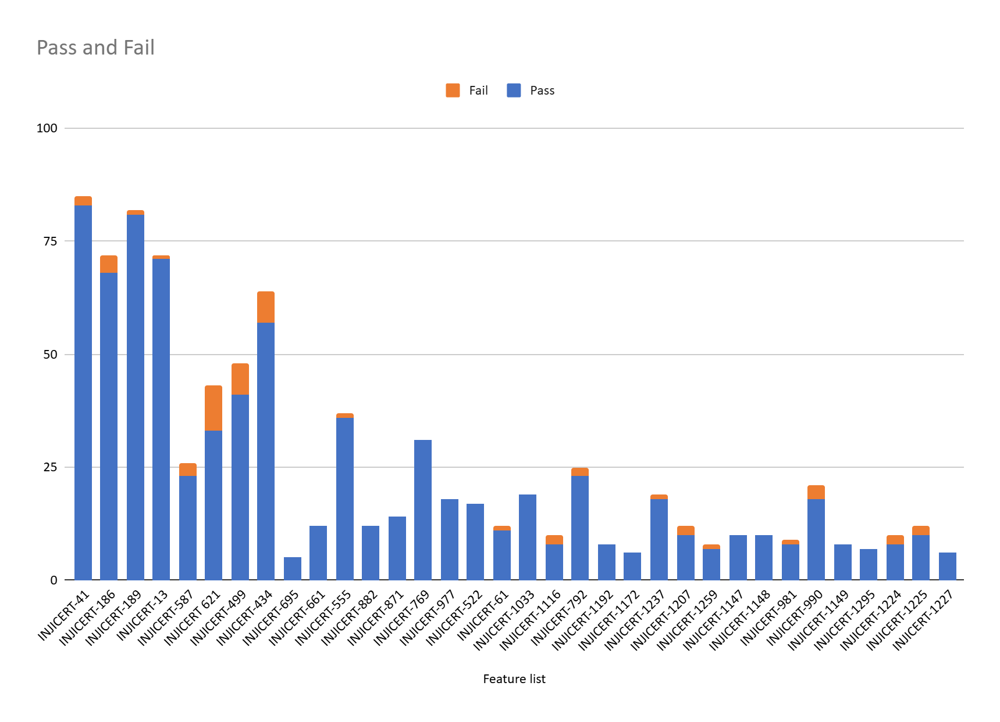

Automation Result
- Sunbird use case
Total | Passed | Failed | Ignored | Known issues
622 | 79 | 0 | 526 | 17
Test Rate: 100%, With Pass Rate: 100% and Fail Rate: 0%

- Mock Use case
Total | Passed | Failed | Ignored | Known issues
622 | 53 | 0 | 552 | 17
Test Rate: 100%, With Pass Rate: 100% and Fail Rate: 0%

- Mock (Data provider) Land registry Use case
Total | Passed | Failed | Ignored | Known issues
622 | 326 | 0 | 279 | 17
Test Rate: 100%, With Pass Rate:97.02% and Fail Rate: 2.98%

- MosipId Use case
Total | Passed | Failed | Ignored | Known issues
622 | 73 | 0 | 532 | 17
Test Rate: 100%, With Pass Rate: 100% and Fail Rate: 0%

- Preauth code(academic) Use case
Total | Passed | Failed | Ignored | Known issues
622 | 28 | 0 | 577 | 17
Test Rate: 100%, With Pass Rate: 90.32% and Fail Rate:9.68%

- PDI (mdoc) Use case
Total | Passed | Failed | Ignored | Known issues
622 | 24 | 0 | 581 | 17
Test Rate: 100%, With Pass Rate: 88.99% and Fail Rate: 11.11%

- Mdoc mdl Use case
Total | Passed | Failed | Ignored | Known issues
622 | 19 | 0 | 586 | 17
Test Rate: 100%, With Pass Rate:95% and Fail Rate: 5%

Defect Metrics

Defect Metrics for the Release 0.14.0
The following table depicts only the bugs which are found and not addressed in the current release.

Table 4: Defect Metrics for the Release

Blocker | Critical | Major | Minor | Total
0 | 0 | 6 | 1 | 7

Conclusion
This section summarizes the key findings of test execution. It also provides a final QA recommendation on the build's readiness for release. The functional verification for Inji certify release version 0.14.0 has been successfully completed. The testing cycle achieved a 100% execution rate with a 97% pass rate across a total of 880 test cases. Additionally, API automation achieved an average of 95% across different use cases.
While there are 18 open defects (14 Major, 4 Minor) and as known issues, there are zero blocker defects that are open. Testing has demonstrated functional stability and data integrity consistent with product specifications.

QA Approval
The build has successfully met the defined exit criteria and is recommended for release. The approval is based on the following satisfied conditions:
- Test Case Execution Completion: 100% of planned scenarios executed.
- Defect Status: No Blocker defects remain open.
- Documentation Sign-off: Reports are finalized.
- Test Environment Stability: The test environment remained stable throughout the execution cycle.

Table 5: Report is signed off details
Name | Functional Role | Responsibilities
Chaitanya K | QA Manager
Ragini Krishna | Senior QA Manager

Appendix
This includes additional reference information for the report. It contains a history of document versions and a list of acronyms and their meanings.

Appendix A: Versions
 | Date | Author | Reviewers
V1.0 | 17/03/2026 | Likhitha R L | Chaitanya K  Ragini Krishna

Appendix B: Acronyms
Acronym | Literal Translation
MOSIP | Modular Open-Source Identity Platform
UIN | Unique Identification Number
VID | Virtual Identification
SVG | Scalable Vector Graphics
SD-JWT | Selective Disclosure - JSON Web Token
VC | Verifiable Credentials
OpenID4VC | OpenID for Verifiable Credentials

END OF DOCUMENT

